MISSION HOSPITAL CASE STUDY ANALYSIS



Name of Student (1): ___Souvik Das________________________

Name of Student (2): ________Varsha Satpathy___________________

Name of Student (3): _____Sam John ______________________

Name of Student (4): ________Nikhil Shah___________________

1. Write Case Summary of Mission Hospital
2. Identify the problems in the dataset and suggest the measure to clean it?
3. Develop a Simple Linear Regression to check if there is association between Total Cost and Body Weight?

After building the Simple Linear Regression model, we found that the Association between the Total Cost and Body weight is very low (I.e 11.78%).

1. Find the correlation between variable "Age", "Body Weight", "Body Height", "Total Length of Stay", "Length of Stay ICU", "Cost of Implant", "Total Cost to Hospital".

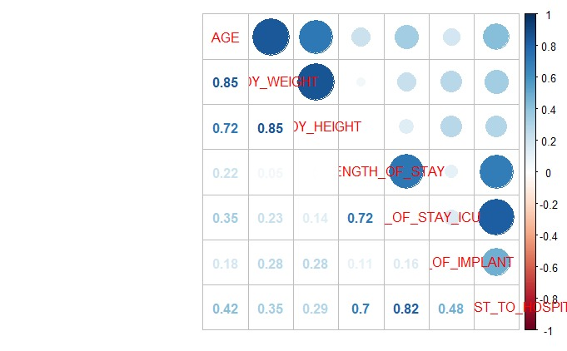

1. Develop a forward Multiple Linear Regression using the relevant variables given in question 4, and identify statistical significant predictors that mission hospital can use to find Treatment Cost? Also do the heteroscedasticity analysis and write the report?

Residuals:

Min 1Q Median 3Q Max

-194395 -21376 1047 20572 458951

Coefficients:

Estimate Std. Error t value Pr(>|t|)

(Intercept) 4.284e+04 8.632e+03 4.963 1.30e-06 ***

AGE 5.397e+02 1.312e+02 4.115 5.31e-05 ***

TOTAL_LENGTH_OF_STAY 5.295e+03 8.466e+02 6.254 1.78e-09 ***

LENGTH_OF_STAY_ICU 1.778e+04 1.236e+03 14.383 < 2e-16 ***

COST_OF_IMPLANT 1.989e+00 1.498e-01 13.277 < 2e-16 ***

---

Signif. codes: 0 ‘***’ 0.001 ‘**’ 0.01 ‘*’ 0.05 ‘.’ 0.1 ‘ ’ 1

Residual standard error: 49560 on 243 degrees of freedom

Multiple R-squared: 0.8392, Adjusted R-squared: 0.8365

F-statistic: 317 on 4 and 243 DF, p-value: < 2.2e-16

